

L&T

EDUTECH

FRONT END

UI UX

MINIPROJECT



PROJECT 2: RECIPE BLOG TEMPLATE

SUBMITTED BY :

AMAL

KJ (2460323) ,

AMAL.KJ@BTECH.CHRISTUNIVERSITY.IN

AUSTIN K

LUKOSE

(2460342)

,

AUSTIN

.K@BTECH.CHRISTUNIVERSITY.IN

TOVIN

TOM (2460468),

TOVIN.TOM@BTECH.CHRISTUNIVERSITY.IN

COURSE: UI UX

FUNDEMENTALS

INSTRUCTOR NAME :NARENDRA

DATE OF SUBMISSION

:

**Abstract**

This project centers on crafting a **Recipe Blog Template** using pure HTML5 and CSS3. It aims to offer a clean, responsive, and semantically organized platform to showcase culinary content such as ingredient lists, preparation steps, and recipe descriptions. Core technologies include semantic HTML5 for structure and CSS Flexbox/Grid for responsive design. The end result is an accessible, intuitive template—optimized for desktop, tablet, and mobile —that functions as a polished foundation for any food-related blog. It serves as both a visual and functional template, ideal for food enthusiasts and bloggers.



**Objective**

The primary objectives are:

**1.**

**Design a user**

**-**

**friendly interface using modern UI principles**

**2.**

**Develop a fully responsive layout using only HTML and CSS**

**3.**

**Implement structured HTML5 semantic elements**

**4.**

**Apply CSS styling for branding, layout, and responsive behavior**

**5.**

**Ensure accessibility and readability across devices**



**Scope of the Project**

•

**Front**

**-**

**End Design Only**

:

Focused exclusively on the

HTML and CSS layer; no JavaScript or server

-

side logic

involved.

•

**Device Compatibility**

:

Fully optimized for desktop,

tablet, and mobile viewports.

•

**Pure Code**

:

No external frameworks or libraries;

relies purely on open

-

source tools and custom code.



**Tools and Technologies**

**purpose**

**HTML5**

:

For clean and semantic structure

CSS3

implements layout (Flexbox, Grid), layout

responsiveness, typography, and color

schemes

Flexbox & Grid

For creating complex, flexible layouts

responsive across screens

Responsive Design Practices

Using media queries and fluid layouts to

adapt to different devices



**HTML Structure Overview**

The template uses semantic HTML5 tags to ensure clarity and accessibility:

•

<

header

>

and

<

nav

>

for branding and navigation links

•

<

main

>

wraps multiple

<

section

>

s such as Featured Recipes, Ingredient Lists, and Instructions

•

A

<

footer

>

contains author or copyright info

This layout aids screen readers, improves SEO, and supports maintainable code structure.



**CSS Styling Strategy**

•

Single external stylesheet (

style.css

)

with commented sections for structure, layout, and responsiveness

•

**Flexbox**

used for one

-

dimensional layouts like ingredient lists

•

**Grid**

applied for structured recipe galleries

•

**Media Queries**

ensure layouts adapt smoothly across viewports

[The Linux Cod](https://thelinuxcode.com/html-css-tutorial-build-a-recipe-website/?utm_source=chatgpt.com)

[e](https://thelinuxcode.com/html-css-tutorial-build-a-recipe-website/?utm_source=chatgpt.com)

•

Mobile

-

first styling enhances performance and user experience

|  |  |
| --- | --- |
| **Key Features** | **Description** |
| Fully Responsive Design | Optimized for smooth viewing across desktop, tablet, and mobile devices. Layouts adapt gracefully using CSS Flexbox, Grid, and media queries for a seamless reading experience. |
| Semantic HTML5 Structure | Utilizes meaningful tags like <header>, <nav>, <main>, <section>, and <footer> to improve accessibility, SEO, and maintainability, following web standards for structured markup. |
| Organized CSS with Flexbox & Grid | Uses Flexbox for ingredient lists and smaller layout  segments, and CSS Grid for complex structures like  photo galleries or recipe cards. This allows for clean,  flexible styling and responsive layouts  [Wikipedi](https://en.wikipedia.org/wiki/CSS_grid_layout?utm_source=chatgpt.com)  [a](https://en.wikipedia.org/wiki/CSS_grid_layout?utm_source=chatgpt.com)  .  **Smooth Navigation with "Jump to Recipe" Links** |
| Content-Centric Design with Visuals | Features structured layout for ingredients, method, prep times, and servings. Though simple, it supports expansion with images and clear labels to prioritize usability and clarity |



**Challenges Faced**

**Solution**

Responsive consistency

Overcame inconsistencies across devices

using fluid units and careful breakpoint

testing

Layout complexity

Achieved clean layout without JavaScript

by combining Flexbox and Grid

Semantic vs. visual balance

Maintained accessibility while ensuring

appealing visuals

Debugging

Used Chrome

DevTools

to fix alignment,

spacing, and mobile layout issues



**Outcome**

This project delivers a

**clean, visually appealing, and**

**accessible Recipe Blog Template**

, demonstrating

proficiency in front

-

end development using just

HTML and CSS. It provides an effective and

lightweight framework for content presentation

—

ready to be customized or extended by bloggers and

developers alike.

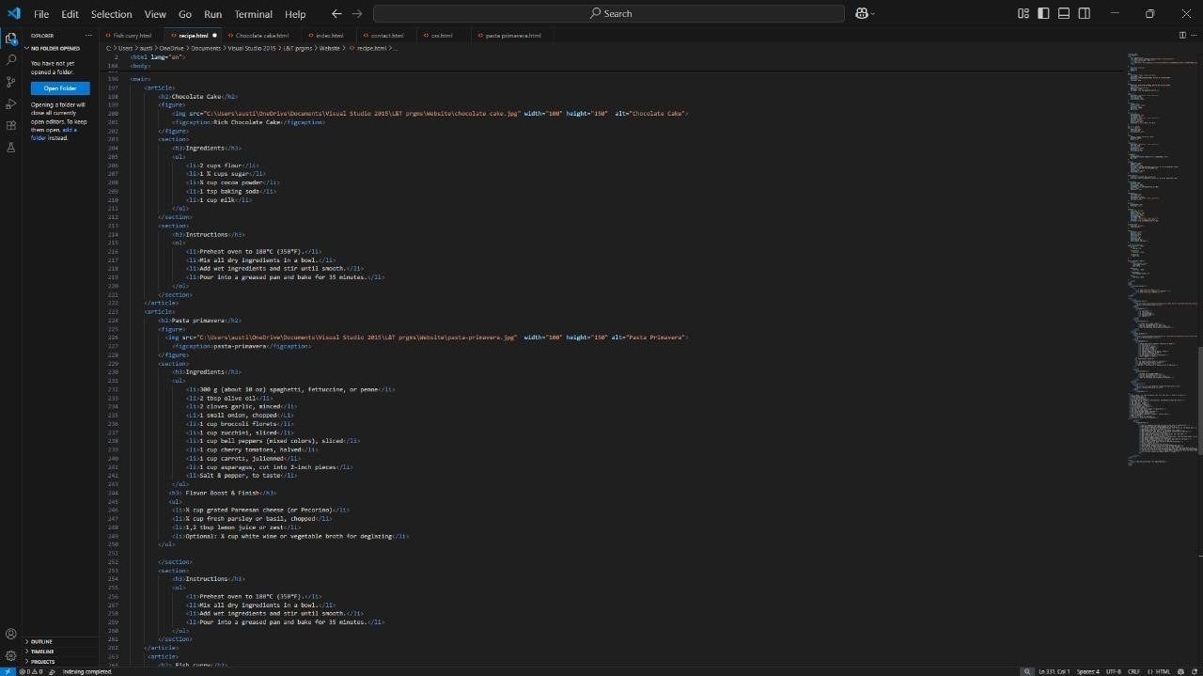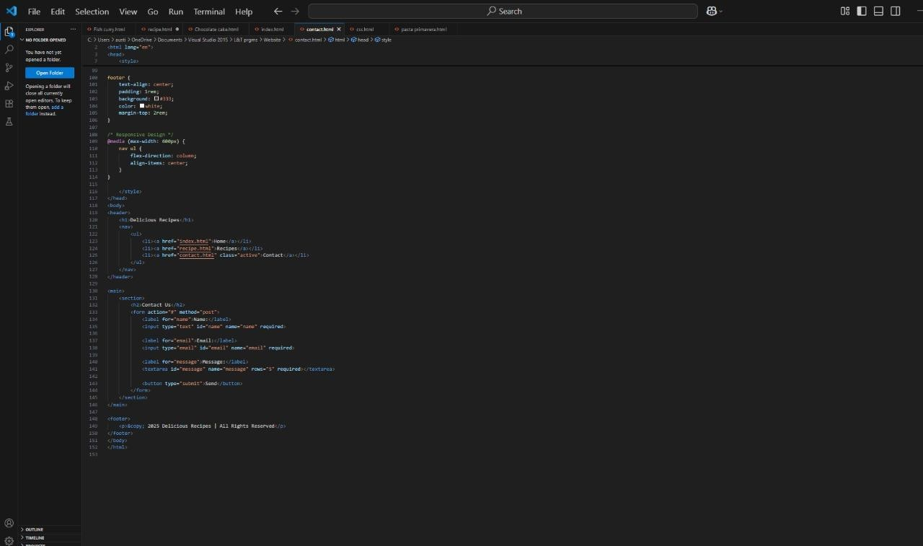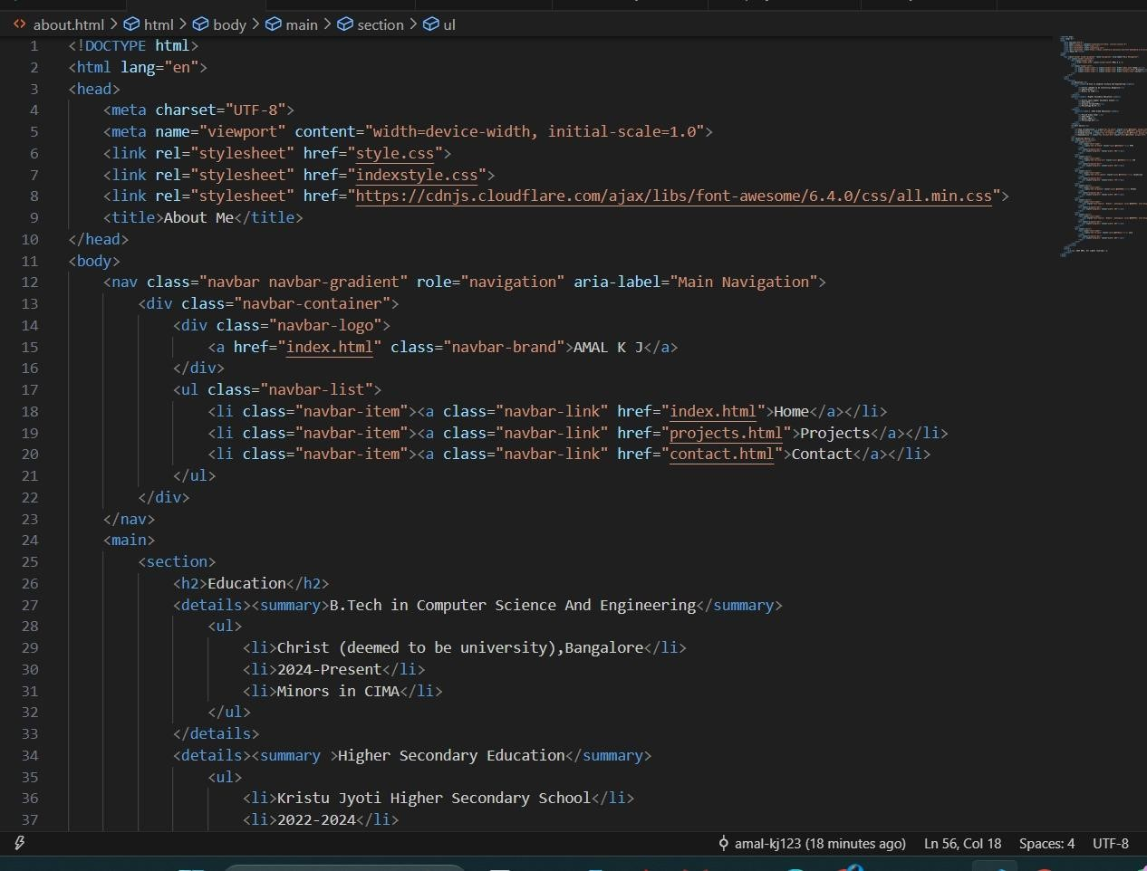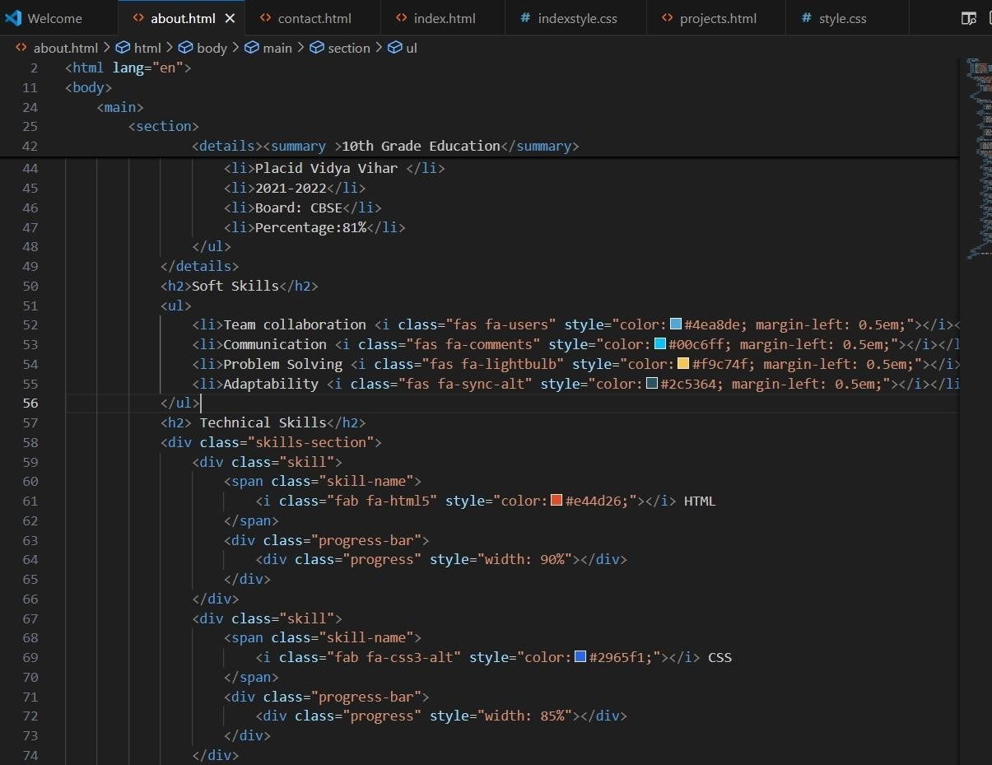

***https://github.com/amal***

***-***

***kj123/HTML***

***-***

***CSS***

***-***

***PROJECT***

***-***

***2***



**Future Enhancements**

•

Introduce

**JavaScript**

for interactive elements

like ingredient toggles or animation

•

Add

**backend integration**

for saving and

retrieving recipes dynamically

•

Apply a

**dark mode toggle**

for better reader

experience

•

Use

**CSS preprocessors**

like SASS and variables

for scalable and maintainable styling

•

Expand templates with

**real**

**-**

**time updates**

for

recipe comments or featured posts



**Conclusion**

This Recipe Blog Template showcases solid front

-

end

skills

—

creating a responsive, visually clean, and semantic

framework using only HTML and CSS. It serves as a

robust foundation that could easily evolve with

JavaScript or backend functionality for richer interactivity

and content management.



**References**

•

Recipe page layout concepts and

mobile

-

first grid patterns

[The Linux Cod](https://thelinuxcode.com/html-css-tutorial-build-a-recipe-website/?utm_source=chatgpt.com)

[e](https://thelinuxcode.com/html-css-tutorial-build-a-recipe-website/?utm_source=chatgpt.com)

•

CSS Grid usage for responsive layout

design